PHP information retrieval and insert with PDO workshop

In this workshop, you are going to re-cap querying MySQL database tables using PHP, but now using PDO to retrieve the records contained and output the results to the web browser. You will then re-cap creating a facility to insert new records, but again using PDO.

In the following exercises remember that you will then need to upload copies of each file you create onto your web space on the newnumyspace web server and that to test them you need to enter the appropriate web address into the address bar of your web browser.

Exercise 1: creating the database table that we will need
First, we need to import a .sql file that has already been created for you into phpMyAdmin that contains code to create database tables called nc_category, nc_director and nc_movie for use in this workshop.

- From the E-learning portal (Blackboard) download the file northumbriaCinema.sql and save it to your u drive
- Import the sql file using the phpMyAdmin interface (http://phpmyadmin.newnumyspace.co.uk/) to create 3 tables, called ‘nc_category’, ‘nc_director’ and ‘nc_movie’ in your newnumyspace MySQL database
- Use phpMyAdmin to view the structures of the 3 tables. For nc_movie you will see that it contains the following fields for movie records.
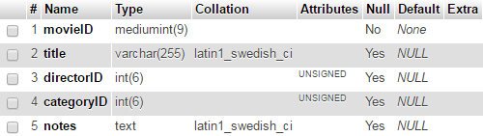

For nc_category you will see the following fields category IDs and the corresponding category names:
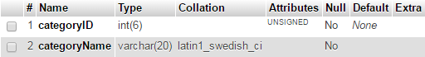

For nc_director you will see the following fields for director IDs and the corresponding director names:
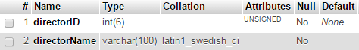
- If you click Browse for each table, you will see the records that they contain.

Exercise 2: re-usable database connection function and script
In this exercise we will create a re-usable script that contains a function (for this workshop and subsequent ones) to make a connection to your MySQL database on the newnumyspace web server using PDO.

- Enter/copy the php code given below into a new php script and give it the filename
functions.php

<?php
function getConnection() {
try {
$connection = new PDO("mysql:host=localhost;dbname=username",
"username", "password");
$connection->setAttribute(PDO::ATTR_ERRMODE, PDO::ERRMODE_EXCEPTION);
return $connection;
} catch (Exception $e) {
throw new Exception("Connection error ". $e->getMessage(), 0, $e);
}
}
?>

- Change the dbname and username to be your newnumyspace username (as in our case they are the same), and the password to be your newnumyspace password.

Note also that the code in this script will be imported in other scripts that will have their own doctype tags etc., so we don’t need to include these in this script.

Exercise 3: querying the database using PHP with PDO
In this exercise, you will query the MySQL table’s nc_category, nc_director and nc_movie using PDO and output the retrieved record details to the web browser.
/
- Add the code provided below into a new PHP script at an appropriate point (remembering to use the basic HTML core tags as a basis). Save it as movieQuery.php into the same location on newnumyspace that you have a copy of your functions.php script

<?php
try {
require_once("functions.php");
$dbConn = getConnection();

$sqlQuery = "SELECT title, categoryName, directorName
FROM nc_movie
INNER JOIN nc_category
ON nc_category.categoryID = nc_movie.categoryID
INNER JOIN nc_director
ON nc_director.directorID = nc_movie.directorID
ORDER BY title";
$queryResult = $dbConn->query($sqlQuery);

while ($rowObj = $queryResult->fetchObject()) {
echo "<div class='movie'>\n
<span class='title'>{$rowObj->title}</span>\n
<span class='categoryName'>{$rowObj->categoryName}</span>\n
<span class='directorName'>{$rowObj->directorName}</span>\n
</div>\n";
}
}
catch (Exception $e){
echo "<p>Query failed: ".$e->getMessage()."</p>\n";
}
?>

This code will
- Connect to the database using the re-usable script and function that you created earlier
- Query the database to retrieve details of each movie record, including the movieID and title held in the nc_movie table and the categoryName and directorName held in the nc_category and nc_director tables that correspond to the categoryID and directorID in the nc_movie table
- Output details of each movie to the web browser, including the movieID, title, categoryName and directorName. The details of each movie will be put inside its own div and the movieID, title, categoryName and directorName will be placed inside span tags.

The div and the span tags are associated with CSS classes. The classes have been added as they would allow you to create some CSS for them to format the output nicely (e.g. to display the records in columns). Try to do this after the workshop.

The output displayed (without the use of any CSS) should look something like that shown opposite. | 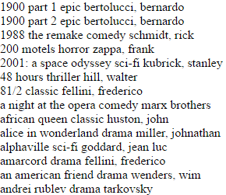

Exercise 4: adding a record
In this exercise, you will add a new movie record to the MySQL table nc_movie (don’t alter the nc_category or nc_director tables) using PDO. First you will need to create a web page that contains a web form that allows the user to enter the details of a new movie.

- Enter/copy the HTML code given below into a new HTML5 web page (remembering to use the basic HTML core tags as a basis first) and save it as addMovieForm.html. It will contain a form that will allow the user to:

  - Enter a title for the movie, select a category and director and enter a description
  - Submit the form

Note that the html provided has been kept deliberately basic for the purposes of clarity. It does not for example contain accessibility features and should use CSS for layout rather than br elements. You could improve the code after the workshop if you wish.

<h1>Add movie</h1>
<form id="addMovie" action="addMovie.php" method="get">
Title <input type="text" name="title">
<br>
Category
<select name="categoryID">
<option value="1">Documentary</option>
<option value="2">Drama</option>
<option value="3">Epic</option>
<option value="4">Comedy</option>
<option value="5">Classic</option>
<option value="6">Thriller</option>
<option value="7">Music</option>
<option value="8">Buddy</option>
<option value="9">Sci-fi</option>
<option value="10">Horror</option>
<option value="11">Series</option>
</select>
<br>
Director
<select name="directorID">
<option value="1">Tarkovsky</option>
<option value="2">Truffault, Francois</option>
<option value="3">Ford, John</option>
<option value="4">Fassbinder</option>
<option value="5">Nichols, Mike</option>
<option value="6">Hitchcock, Alfred</option>
</select>
<br>
Description <br>
<textarea name="notes"></textarea>
<br>
<input type="submit" value="Add movie">
</form>

When viewed in a web browser it should look something like this:

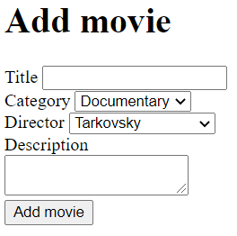

- Create a PHP script called addMovie.php (remembering to use the basic HTML5 core tags as a basis) to insert a new movie record into the nc_movie table using the details entered into the web form using PDO and exception handling. It should:

  - Connect to the database using the re-usable script and function that you created earlier
  - Extract the data sent by the form
  - Use that data to insert a new record into the nc_movie database table using PDO and exception handling, putting the movie’s title, categoryID, directorID and description (notes) from the web form into the corresponding database fields
  - Output a message to the web browser to say a new record has been added to the database.

To help you, the following partial example of code that does a similar job to that needed for step 3 (but with a different table and fields) is provided as a reference. Don’t enter this code.

$sqlInsert = "INSERT INTO feedback (userID, productID, rating)
VALUES ($userID, $productID, $rating)";
$dbConn->query($sqlInsert);

Here the code uses PDO to add a record to a made up table called feedback that has three fields that values from a web form (here stored in variables) for the new record are inserted into.

Directed learning
If you have time in the workshop attempt the exercises on the following page, otherwise attempt them as directed learning.

Exercise 5: improving the add movie form
In this exercise, you will improve the add movie form by building the options for the categories and directors select lists dynamically from the database content. That way they will always stay ‘in sync’ with that.

- Re-save addMovieForm.html to addMovieForm.php
- Modify the code so that the option tags for the category select list are generated dynamically, with one option tag per category from the nc_category table

Resource on Blackboard to help you: the ‘Building dynamic select lists for forms’ section in the “Dynamic select lists and pre-selecting an element.doc” document

- Do the same for the director select list using the nc_director table.

Exercise 6: adding records more robustly
In this exercise, you will improve your addMovie.php script so that it handles undefined index errors and prompts the user to enter details (and only allows a record to be added if all required fields were completed). To do this modify addMovie.php so that it

- Prevents undefined index errors.
Hint: use isset - later we will see that we can also use filter_has_var
- Prompts the user to enter values for form fields that have not been completed and prevents a new record from been added if they have not.
Hint: use empty

